**Phase-End Project 5**

**Automate an E-Commerce Web Application**

**Description:**

Flipkart is an e-commerce platform, and they have launched a new feature to search for a product in a particular category. Once the product is searched, Flipkart displays it as a list of product items. To enhance the performance of the application, Flipkart has implemented lazy loading. It displays only a few products that can come on the screen.

To display or load more products, the user must scroll down.

As a Test Engineer, you are expected to test this feature end-to-end.

Screenshots

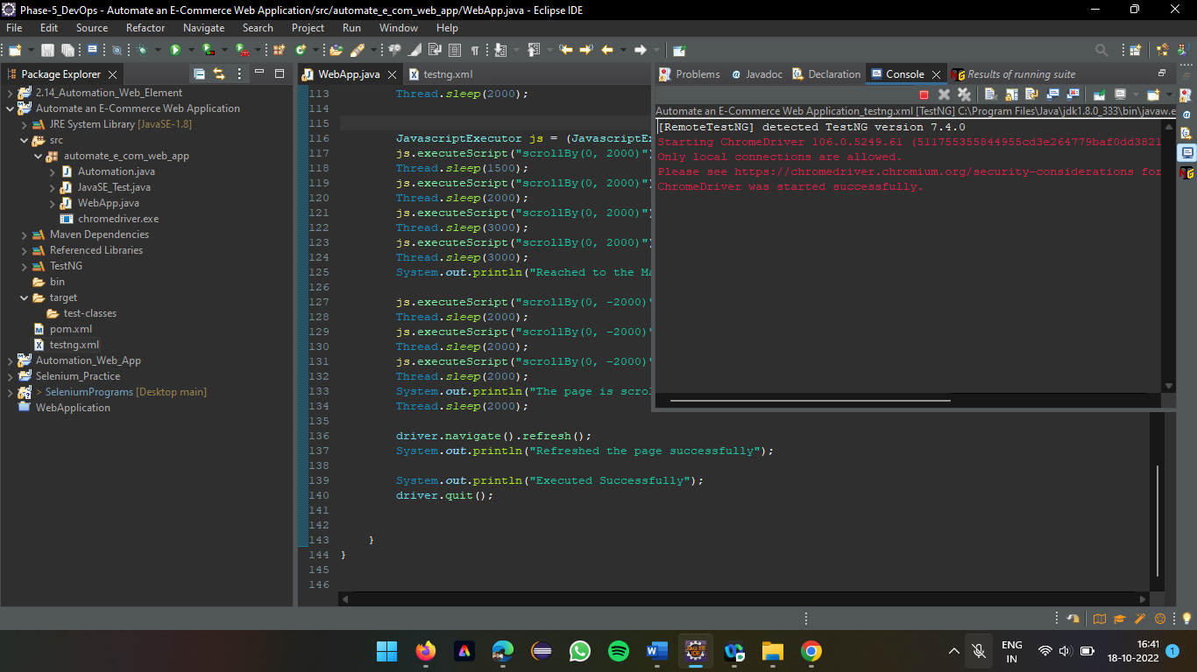

Chrome driver started successfully

Opens the driver of Flipkart web application upon Chrome driver starting

Maximizes to full width display

Displaying User Log in process

Displaying the user’s home page after successful logging in

Displaying the total load time to process and show the contents of Flipkart application

Searching for the product in Search Bar

Displays all the products in the list that matches the text iphone 13

Scroll down feature is active after the images being loaded to view all the products that exists in the list

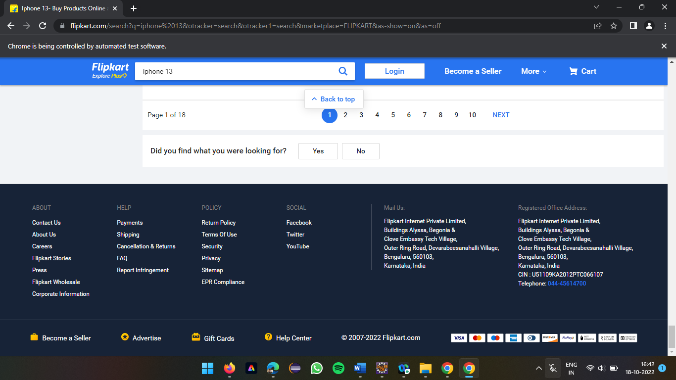

Displaying the bottom of the page height after scroll by method implemented

The page is scrolled to the top after the bottom height is reached

Displaying the console after all the Chrome Driver based testing is completed

Automation of Flipkart application using Firefox (gecko) driver on Firefox browser

Displaying Flipkart home page in Firefox browser, the login process is cancelled

Searching for the iphone 13 in the Search bar

Products are displayed in the list after the search bar matches the text to search for the product

Scroll feature is active on the Firefox browser

The page is scrolled till the page height

The page is scrolled to the top after the bottom height is reached

**Test Results in the console**

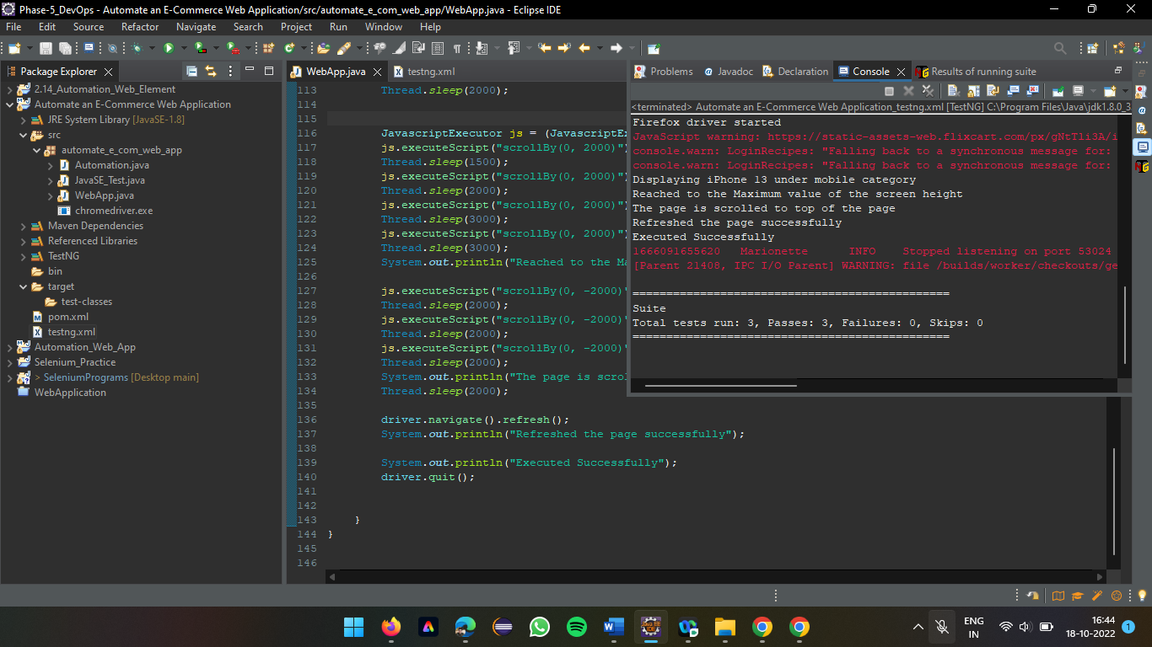

All the tests are passed after successful completion of all the functionalities

All tests are passed (indicated with correct sign and green colour)

Summary of the test run, with the total time taken in seconds to finish up all the processes, number of Class count and Method count